Name: _____________________________

This assessment is a validation test from the investigation into “The exchange of materials by cells”. The investigation is described below to remind you of the procedure and questions have been added for you to demonstrate your understanding of the processes. Please read through the information and then answer the questions that follow.

Objectives:

* understand how materials move into and out of the cell
* understand the process of diffusion
* understand the properties of a differentially permeable membrane

The following activity was performed and observations recorded.

Materials used:

* 1 beaker
* Cellulose tubing
* Starch suspension
* Iodine solution (iodine-potassium-iodide)

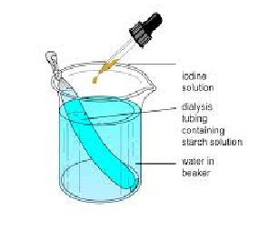Procedure:

* A knot was tied in one end of the cellulose tubing
* The tubing was wet with water and opened so that it formed a bag
* The cellulose bag was half-filled with starch suspension and the other end tied off
* The cellulose bag was rinsed to remove any starch from the outside
* The beaker was filled three quarters full with water
* Iodine solution was added to the water until it was a pale yellow
* The filled cellulose bag was placed into the water/iodine filled beaker
* Observations were recorded

Questions:

1. In this experiment, what represented the cell? _________________________________

(1 Mark)

1. What represented the cell membrane? _______________________________________

(1 Mark)

1. What represented the liquid in which the cell lived? _____________________________

(1 Mark)

1. Describe any colour changes that would occur in this experiment.

______________________________________________________________________

______________________________________________________________________

(2 Marks)

1. What would cause the colour change?

______________________________________________________________________

______________________________________________________________________

(2 Marks)

1. Describe any changes that would occur to the volume of the cellulose bag.

______________________________________________________________________

(2 Marks)

1. What would cause this change? _______________________________________

(2 Marks)

1. Which has larger molecules: starch or iodine-potassium-iodide? Explain your answer.

____________________________________________________________________________________________________________________________________________

(2 Marks)

1. Why didn’t the starch molecules move out of the tubing? _________________________

(1 Mark)

1. Name the two processes involved in this experiment and give a description for each.

________________________________________________________________________________________________________________________________________________________________________________________________________________________________________________________________________________________

(6 Marks)

1. In a living cell what kinds of substances would enter or leave? List as many as you can.

__________________________________________________________________________________________________________________________________________________________________________________________________________________

(3 Marks)

1. Predict what would happen if an isolated animal cell were placed in distilled water.

_____________________________________________________________________

(2 Marks)